
Certificate of Analysis

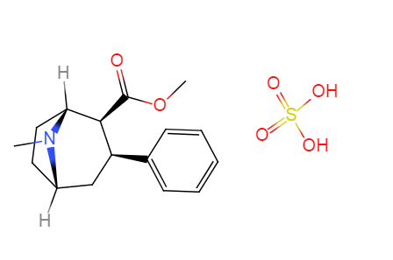
Troparil sulfate
Brand Name :Biochempartner
M.Wt: 357.1246
Formula: C16H23NO6S
Batch NO: 20190916

Item | Specification | Results
Appearance | Light yellow powder | Conforms
Identification | NMR;HPLC | Conforms
Assay | >98% | Conforms

Conclusion: Complies with In-house standard.
QA manager :kexianxun
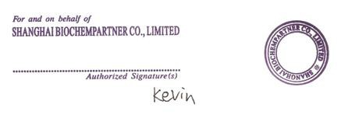

manufacturing site name: ShangHai BiochempartnerCo.,Ltd
Address :No.1616 ZhangJiangRoad,PuDong NewDistrict,ShangHai,China ,201203

